Trend letter I June 2022

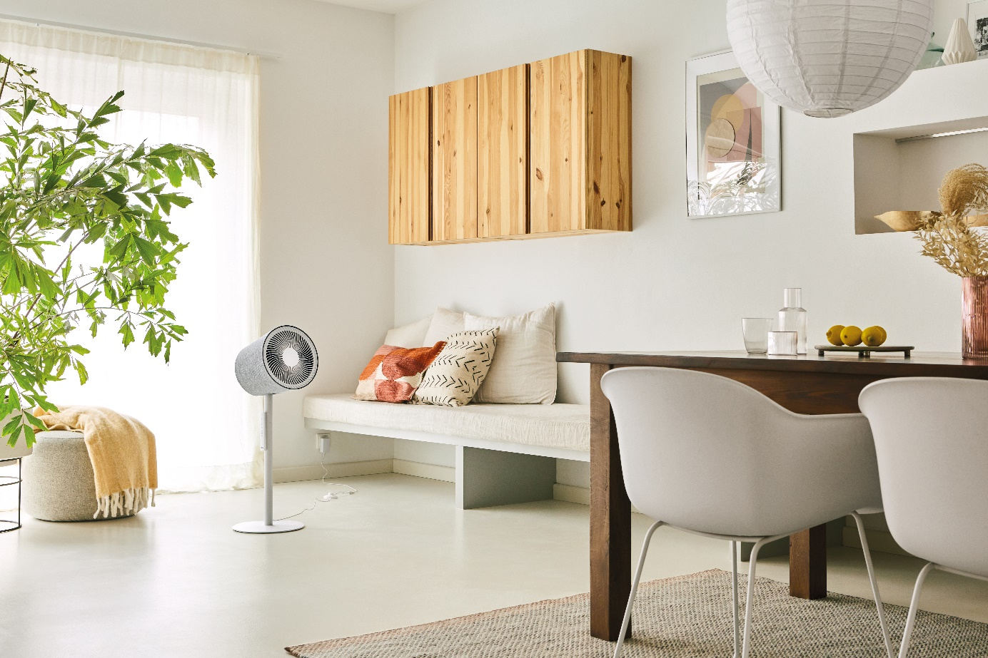
Stylish all-round refreshment for restful summer nights
New favourite for summer: 3D fan Simon from Stadler Form for design fans
High temperatures are particularly uncomfortable at night: stuffy air turns cosy oases of well-being into sauna-like areas and often leads to sleepless nights. But with a fresh breeze, you won’t have any problems getting to sleep – even in summer. Stadler Form took on the challenge and collaborated with two Swiss product designers to create a 3D fan that is both functional and aesthetically pleasing. Thanks to his innovative technology, 3D fan Simon can provide all-round refreshment in your home.
A special cooling experience

To enjoy restful sleep even when the temperature starts to rise, make sure that the air in the room is not still. Why? Because circulating air feels cooler than still air. The newly launched Simon from Stadler Form, with his innovative 3D oscillation, is the perfect remedy. As soon as you switch him on, the top part swings horizontally and vertically in both directions in swivel mode. The air that he circulates cools you down by wafting away the warm layer of air on your skin and replacing it with cooler dry air. This makes it easier for sweat to evaporate and for you to get a comfortable night’s sleep. Simon goes about his business quietly so as not to disturb your dreams on hot summer nights.
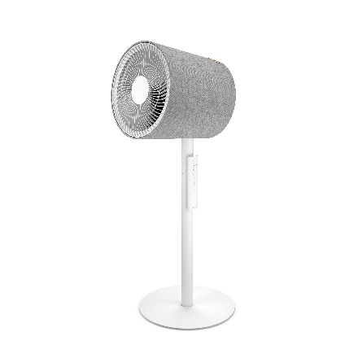
You can enjoy the all-round circulation from your bed and control the fan using a magnetic radio remote control. Simon gives you 10 speed settings to choose from, ranging from cool breeze to strong wind. Tip for the bedroom: it’s best not to put Simon too close to the bed. With his 10-metre range and pedestal for optimum height, you will still be able to feel the refreshing breeze from a distance!

Further highlights: a 1-7 hour timer means that Simon will only stay on for as long as you want him to and then switch off automatically. With his minimalistic design and modern textile cover, Simon is sure to be an eye-catching addition to any room in your home.

Family photographer & influencer Isabelle Kade relies on Simon

«When I saw Simon for the first time, I was blown away. First of all, he doesn’t look anything like a typical fan. The textile cover and special shape make Simon a design object. He was easy to operate and extremely intuitive at the same time. My girls and I tried out Simon. The little ones were captivated by the way he moved round and I totally enjoyed the circulating air from the comfort of my sofa. Wonderful! Naturally, as a photographer I also pay a lot of attention to the aesthetics and harmony of interiors. And I was fascinated at how beautifully Simon fitted in with his surroundings. As a mum, I like to use the off timer which helps me enjoy the refreshing breeze when I get time to kick back and relax in my hectic everyday life», says Isabelle Kade, Swiss influencer and family photographer.

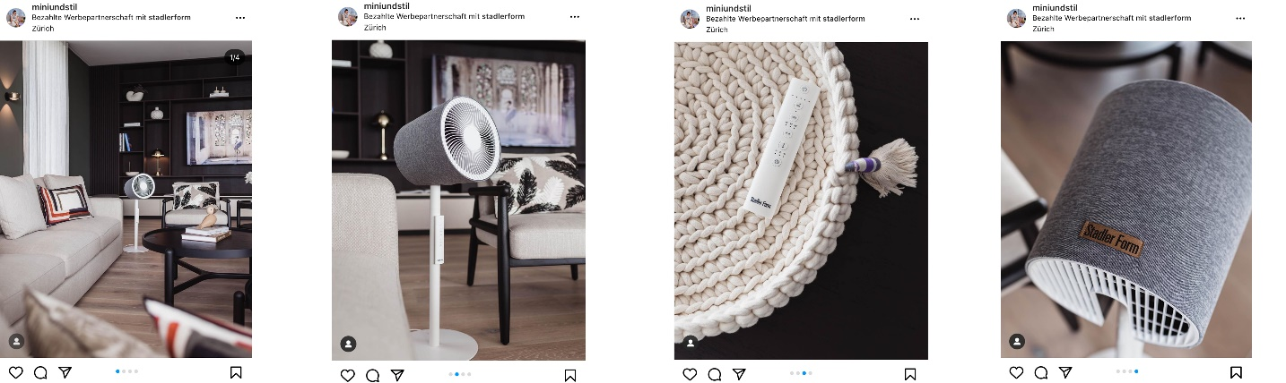

Click here for the post

3D air circulator Simon from Stadler Form, current webshop price Fr. 229.90.-

Fan Simon from Stadler Form is available via stadlerform.com and in selected specialist stores as well as their online shops.

Please do not hesitate to contact us for further information.

Press contact:

Silvia Acerra
Flowcube Communications | E-mail: silvia.acerra@flowcube.ch | Tel. +41 (0)43 344 30 35

